**Using Bloom’s Taxonomy For Business**

Bloom’s Taxonomy is something you typically hear about in regards to a K-12 classroom, not in regards to a business environment. I would argue that Bloom’s Taxonomy is as important for business as it is for a classroom if not more important. Bloom’s Taxonomy has levels of learning that are as follows:

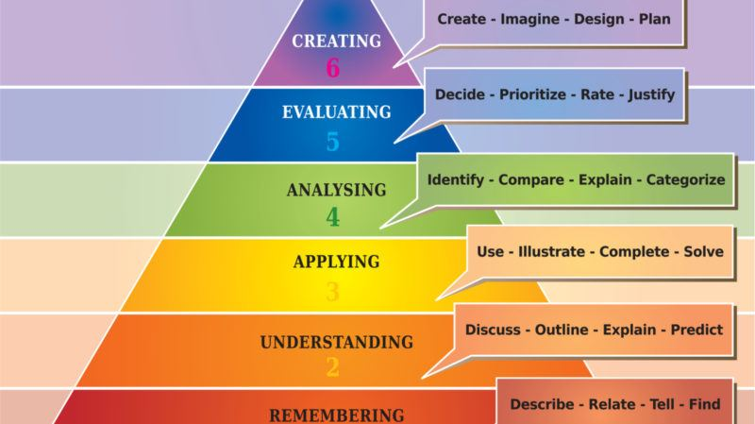

artellia/Shutterstock.com

As you move up the levels, the learning that occurs is more complex and needs more support either in a training session, via an eLearning course or in subsequent follow-up sessions or job aids. The complexity of the thinking and the connections that need to occur need more time, practice and support.

Here are some examples of the kind of learning that could occur on each level. There are thousands of examples that could be used.

* **Create**  
  It could be how to use a new CAD system to design a car part.
* **Evaluate**  
  It could be to weigh the new features of a new tool or system.
* **Analyze**  
  It could be to assess the features of several new products and contrast the benefits to your organization.
* **Apply**  
  It could be to utilize a new tool to make a sale to a customer.
* **Understand**  
  It could be to understand the new contract language and how it applies to your job.
* **Remember**  
  It could be that the information needed is in a job aid and where to reference that job aid.

**Creating A Measurable Objective**

While an Instructional Designer is meeting with a Subject Matter Expert, they need to identify the objectives of the training. Bloom’s Taxonomy levels help to identify and create objectives and codify what you are asking the learner to be able to do when the session is complete. I find that [the verb chart](https://www.mesacc.edu/employees/course-management/curriculum/resources/blooms-higher-level-verbs) helps me to brainstorm the most effective objectives quickly and succinctly.

When I was a classroom teacher, each day, I was required to write the objective of each class on my board. It started with I can _________________by  _________________. For example, I can understand the parts of a cell by creating a model of it. Or I can differentiate the carbon cycle from the nitrogen cycle by comparing and contrasting their inputs and outputs.

When applied to a business situation, we can create the same kind of objectives. I can utilize the loan beam system by discovering how to input loan documents and completing a test loan.

Or

I can apply the correct scheduling rule in the new system by accessing the flowchart for the appropriate scenario.

After you have identified your objectives, think about how you will measure them.

For our first objective, I can utilize the loan beam system by discovering how to input loan documents and completing a test loan.

You can measure your learner’s effectiveness by two outcomes for this goal. First, they can use the new system as evidenced by the inputting of a test loan, but more importantly, they can input a loan into the production system. This is easy to see evidence of success, as either they did it or they did not, and need additional support. If they need additional support, identify where they needed assistance. Consider changing how the training is delivered so more are successful for future learners.

Our second objective is that I can apply the correct scheduling rule in the new system by accessing the flowchart for the appropriate scenario.

This can be measured by looking at who was scheduled and if the correct rule was utilized. If it was not used correctly consider how to improve the use, ask: is it additional training, emails with situational examples, or coaching by the team leader?

There are as many ways to remediate an objective as there are ways to create one. Spending time with your SME clearly identifying objectives helps to focus the contents of the course and create measurable learning. As you work with the SME to storyboard your course, keep the objectives in mind as you go through each step.